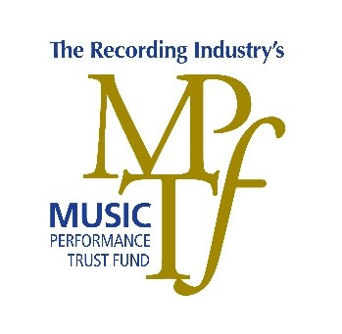
The Music Performance Trust Fund’s Music Family Scholarship Application
The Music Performance Trust Fund invites young adults who have grown up in a musical family to tell us their story! Applicants must be a child of a professional musician, and pursuing further education after high school. The program is open to qualified students who meet all the minimum qualifications. Open to all students in the United States and Canada. Scholarships will be awarded based on the successful completion of this application form; the strength of the applicant’s essay; and the representation by the applicant that all answers are true. Please complete all items in the application and essay page/s within.
Print and sign this document, then scan or photograph each page to be uploaded and sent by email. Send an email with the subject line, “2020 Music Family Scholarship Application” to scholar@musicpf.org and attach this document as a PDF or Word doc.

Applicant Information
Full Name: |  |  |  | Date of Birth:
 | Last | First | M.I.

Address:
 | Street Address | Apartment/Unit #

 | City | State | ZIP Code

Phone: |  | Email

Education
High School: |  | Complete Address:

Dates From: |  | To: |  | Did you graduate? | YES | NO | Date of diploma:

Trade, School, College, University: |  | Complete Address:

Dates from: |  | To: |  |  | Area of Study or intended Major:

Parent Contact Information
Please list parent who belongs to a local musicians’ union.
Full  Name: |  | Your Relationship:
Union Local Name: |  | Phone:
Address:
Member #

Musician’s Union Contact Information
Please list an officer of the local musicians’ union.
Full Name: |  | Title:
Union Local Name |  | Phone:
Address:

Disclaimer and Signature
The Music Performance Trust Fund reserves the right to share the information you provide on this form to celebrate the power of music with others. “By signing and submitting this application, you approve our use of your essay for any and all purposes related to the Music Performance Trust Fund, to musicians, to the American Federation of Musicians or to any other aspect of the music business or the performing arts. We will not use your name without permission”.
I certify that my answers are true and complete to the best of my knowledge.
I understand that false or misleading information in my application or essay may result in my being disqualified.
Signature: |  | Date:

Music Family Scholarship Application Essay
Please take the next 1-2 pages to complete a personal essay. Here you may reveal your unique voice and enthusiasm, self-awareness, aptitude, and commitment for learning and growing. Tell us your stories, including any relevant experiences, interests, insights. We seek brief yet compelling 500-750 word essay that describe your personal experience of growing up in a ‘music family,’ and your vision of the impact this has had - and will continue to have - on your life. How have your experiences been an inspiration towards your career path? You may choose one or more of the prompts below to help shape your essay:
- What does it mean to grow up in a music family?
- How has the experience of being the child of a professional musician shape your perspective and your values or philosophy of life?
- What have been your challenges, opportunities, uniqueness of experience, lessons learned?
- What has this experience taught you that may help you in the next chapter of your life?
Write your essay of no more than 2 pages in the space provided below; take additional page if needed.

